Passport Assistance

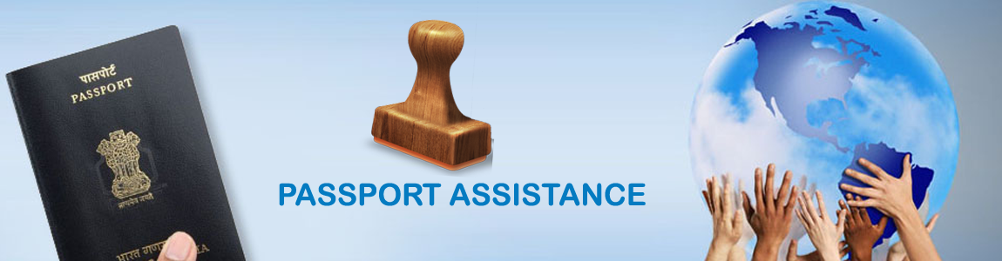
We at Time 2 Journey offer prompt passport assistance to our clients. Our group of professional ensure dedicated and comfort service, so our clients enjoy hassle free travelling with friends and family. We guide clients in knowing the documents required for obtaining passport within the time frame.
Passport is the most important identity proof issued by the Indian government, and is highly used as a part of document in every registration. More importantly, if you are planning to travel abroad, then passport is the foremost document that needs to be obtained. It highlights name, DOB, nationality, address and photo identity. It is highly required whether you are shifting to a new city, getting registered to any service or applying for a job in your or other country.
Now with the online registration available, you can use Time 2 Journey for passport assistance and get the documentation done without any hassle.
Passport Assistance Service we offer:
- Fresh/New Passport Application Assistance
- Tatkal and reissue of Passport
- Exhaustion of Pages Application Assistance
- Police Clearance Certificate Related Assistance
- Identity Certificate Related Assistance
We also assist in passport renewal if the expiry date is nearing. If you or any of your family members doesn’t hold a passport, then do contact us now to get all the required assistance for issuing.

